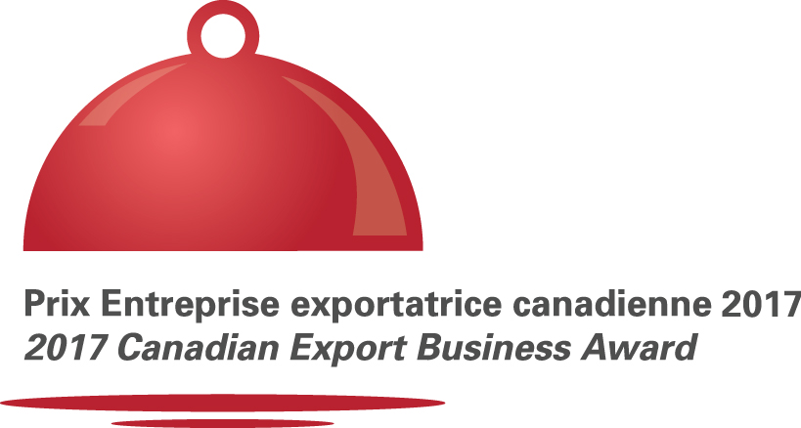


In partnership with


Application Form

Application deadline: March 17, 2017

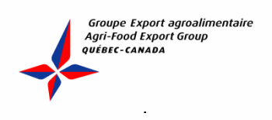

The prestigious 2017 Canadian Export Business Award, created by Agri-Food Export Group Québec-Canada, is now in its eleven year. It will be presented to the Canadian agri-food business that has demonstrated the most outstanding achievements on international markets in 2016. The prize serves as a springboard to an enhanced reputation and increased visibility and recognition on international markets.

The winner of the 2017 Canadian Export Business Award as well as the finalists will enjoy valuable exposure in the media and industry when the prize is awarded during the «Networking event of the Agri-Food Industry», on May 2, 2017 at the Allstream Centre of Toronto during SIAL Canada. This is a unique opportunity to have your company shine on the international stage—be it small, medium-sized, or large.

The Networking Event of the Agri-Food Industry draws over 400 of the biggest players in the industry. It’s an excellent networking opportunity. The event is initiated by Agri-Food Export Group Québec-Canada.

Don’t wait. Enter your company now!

MEDIA EXPOSURE FOR THE FINALISTS

- Mention in press release announcing names of finalists before the event
- Mention of the finalists in the Export Group newsletter
- Mention of the finalists on the Export Group website
- Presentation of the company's products in a showcase display during the three days of SIAL at the Export Group’s Pavilion
- Name and logo of business displayed repeatedly on screen during the event
- Business mentioned and its representative introduced on main stage upon event opening
- Display of your products in a display case during the event (value of 250$)
- Official photo of business’s representative
- Two tickets for the Networking Event (value of 500$)

AWARD WINNER’S EXCLUSIVE BENEFITS AND PRIVILEGES

- Mention in press release announcing the winner after the event
- Mention of the winner – with picture - on the home page of the Export Group website (9 months)
- Press kit sent to Canadian embassies and trade commissioner
- Press kit sent to Canadian and American media
- Article about the business in June 2017 issue of Export Group’s newsletter, with link to business’s web site
- Article in the Actualité Alimentaire magazine
- Inclusion in Export Group’s press release announcing winner on SIAL Canada’s web site
- Publication of an article from the company in one Export Group newsletter in 2017
- Use of “2017 Canadian Export Business Award” logo

Estimated value of your brand’s visibility: $3,000

APPLICATION FORM

ELIGIBILITY

To be eligible for the 2017 Canadian Export Business Award, your company must be a Canadian farming and/or food processing business that has been exporting its products for at least three years and have revenues of over $3M.

Please note that trading houses and companies in the service and distribution sectors are not eligible.

All information provided herein will remain confidential and all applications will be destroyed following the selection process.

REGISTRATION

Company Name
Address
City
Province |  | Postal Code
Telephone |  | Fax
Email
Website
Person in Charge
Title of Person in Charge
Head Office Address if Different
Organization who suggested you to apply
Person’s Name

SUMMARY DESCRIPTION OF COMPANY

A -Company overview

Date of foundation (month/year):
Date of acquisition if applicable (month/year):
Number of permanent employees: Seasonal employees (If applicable):
Date exports began (year):

B - Main company officers and/or managers.

Name | Position

C - Please provide a brief mission statement and business strategy

D - Canadian products exported. (For the purposes of this award, a “Canadian Product” is defined as a product grown, harvested or processed and packaged in Canada. A product containing imported components may also be considered Canadian for the purpose of this policy when it has undergone sufficient change in Canada, in a manner that satisfies the definition specified under the North American Free Trade Agreement (NAFTA) Rules of Origin)

E - List your main export products with % of Canadian ingredients and % of export value that they represent.

Product’s Name | % of Canadian ingredients | % of Export Value
Other products
Total : |  | 100%

Safety Standards and Certifications

F - Specify certifications obtained and health and safety programs implemented over the last years and as well as those in the process of being obtained, if applicable.

DETAILED INFORMATION REQUIRED FOR EVALUATING CRITERIA

1) Information on sales (to be eligible for the award, the company must have had a minimum of $3M in sales in the last business year)

  - Indicate your sales for the past three years according to the following categories:

 | Year 2014 |  | Year 2015 |  | Year 2016
 | Sales | % | Sales | % | Sales | %
Total Sales
Domestic Sales
Market outside your Province
Sales USA
Sales other countries

  - List the countries in which you can claim more than 5% of your exports

Country | % Export
Other countries
Total :

  - In how many countries are you active?

/25

- Your company has significantly increased its presence on export markets over the last three years. Describe your main achievements and the greatest challenges you faced. If a particular market/country was especially successful, explain why.
/20

- Emphasize the innovative approaches you employed to be competitive on the international market.
/15

- Describe how the company has adapted its products to demand on its various export markets (packaging, sizes, recipes, branding, etc.). /15

- Goals and Markets for the next two years

5.1) What are your target markets (countries, provinces/states, sectors of activity) from now to 2018 and why?

5.2) Please quantify your target:

 | Year 2017 |  | Year 2018
 | Sales | % | Sales | %
Total Sales
Domestic Market
Market outside your Province
Sales USA
Sales other countries

  - What will be your strategy to develop your goals in the next two years (action plan, first steps to achieve export plan).
/15

- Briefly indicate why you think the jury should retain your application for the 2017
Canadian Export Business Award. /5

EVALUATION

CRITERIA | POINTS
Information on sales – Point 1 | 25
Increase on export markets – Point 2 | 20
Innovative approaches – Point 3 | 15
Adaptation strategy – Point 4 | 15
Goals and Markets – Point 5 | 15
Why you think the jury should retain your application – Point 6 | 5
Overall quality of the application – (For committee only) | 5
TOTAL | 100

For committee use only

The company meets all competition criteria.

Yes □ No □

The overall quality of the application is noteworthy. /5

Note:
All sections of this application must be completed, failing which your company’s application will be automatically rejected. Do not hesitate to use more space to answer questions if needed.

DECLARATION
I have read and understood the contest rules and certify that all of the information provided is true.

Name: Position:

Signature: _____________________________ Date: _______________

Along with your application, please enclose 2 copies of your corporative brochure and/or of your products’ promotional material. Do not send products.

Dates TO REMEMBER

- Applications must be received by Export Group on or before: March 17, 2017
- Finalists to be announced: April 17, 2017
- Winner to be announced on May 2, 2017

ConfidentialitY

Export Group undertakes to ensure the confidentiality of all information provided herein. Members of the organizing committee and jury have signed a confidentiality agreement. Moreover, only jury members will have access to the information contained in applications. All applications will be destroyed following the selection process.

Your application must be received in a sealed envelope
AT THE LATEST BY March 17, 2017 at the following address:

2017 Canadian Export Business Award
Agri-Food Export Group Québec-Canada
1971, Léonard-De Vinci
Sainte-Julie (Québec) J3E 1Y9
c/o Francine Lapointe

Information: Véronique Folny
T 418 456-7854 – Email : veroniquefolny@groupexport.ca

Congratulations to previous winners

2016 Fruit d’Or, Villeroy, QC

2015 Olymel S.E.C./L.P, Boucherville, QC

2014 O’Sole Mio, Boisbriand, QC

2013 F. Ménard inc., Ange-Gardien, Québec

2012 Tergel inc., Terrebonne, QC

2011 Citadelle, Maple Syrup Producer's Cooperative, Plessisville, Québec

2010 Veg Pro International inc., Sherrington, Québec

2009 Les Viandes Du Breton inc., Rivière-du-Loup, Québec

2008 Origin Organic Farms inc., Delta, British Columbia

2007 Bio Biscuit inc., Saint-Hyacinthe, Québec

